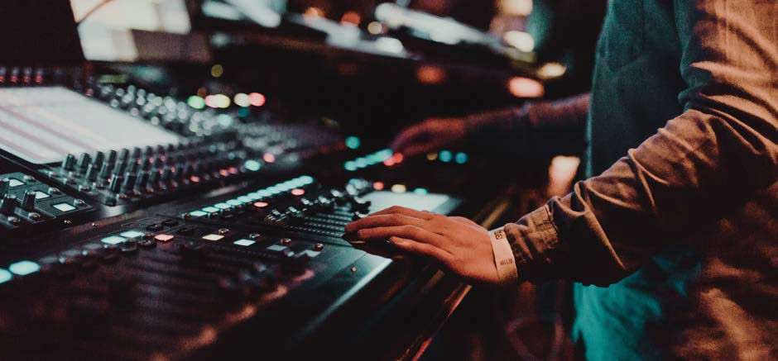
🚧

J3ZZ Tech rider
Last updated : 28.06.2023

The venue shall supply the following:

Front Of House
A high-quality audio system meeting the following requirements has to be set up and be in full working order 1 hour prior to sound check. A high-quality stereo three-way active PA system with Subs capable of providing a clear non-distorted sound with an even coverage of sound throughout the venue and capable of delivering a range between 30hz-20khz.Center fills were required.

Required audio equipment :
Analog audio mixer, Midas,Yamaha, Soundcraft etc.. or digital audio mixer Midas M32 with USB capable recording.
48 ch. min. If Analog we need EQ for all outputs 6 x monitor mixes ( Why is it 6 mixes if its only 3 stereo?)
FX-Reverb FX-Tap delay

Dynamics:
4 x gates Drawmer,BBS or comparable 6 x compessors DBX
48 x 12 stage box,all cabling,

Required lighting:
Stage lighting to be enough to cover the stage in a wash with colored filters and, or LED lighting colors tbd .
12 x moving head fixtures Robe, Clay Packy, Mac Intelligent lighting console for Moving heads Lighting operator for rehearsals and show

Required Projection:
12-20k lumen laser projector HDMI connection at FOH laptop
Projection screen to accommodate room size

Required Backline:
Drums
Ludwig, D&W 20" bass drum 12" Tom
14" floor tom
14" snare drum
1 drum throne
1 bass drum pedal 1 Hi hat stand
3 cymbal stands
1 Snare stand

Drum carpet

Keys
1 Nord stage 2, 3 or 4
1 keys stand
1 keys seat

mic stands :
12 boom mic stands 6 mini boom stands
5 vocal mics ( I only see 1 Vocal input on your list what are the other 4 for?)
6 x percussion mics
16 x DI boxes with ground lifts 8 x monitor wedges for stage

Artist stage needs:
Stereo Monitors L-R at artist position on stage
1 STANDING HEIGHT 110 CM table with black covering 160-200 wide x 80cm deep 1 x 16-amp independent circuit at stage position
A sober English-speaking AV Technician who is experienced with the equipment and is to be available to assist for the duration of the artist’s visit to the venue.
All system control must be visible to our engineer if we are traveling with one , If not we will depend on the house staff for Sound, video, and lighting support.

Artist And crew catering:
From designated start/load in time until complete de rig of show have still and sparkling water, tea, coffee, available.
Lunch, dinner cold and warm food

Channel Input list / PATCH

01 | Kick drum- MIC | MAIN
02 | Cajon -MIC | MAIN
03 | OVR HD/PERC MIC | MAIN
04 | SPDX-L- DI BOX | MAIN
05 | SPDX-R-DI BOX | MAIN
06 | LAPTOP-L DI BOX | MAIN
07 | LAPTOP-R DI BOX | MAIN
08 | Nord stage chan 1 DI BOX | MAIN
09 | Nord stage chan 2 DI BOX | MAIN
10 | Nord stage chan 3 DI BOX | MAIN
11 | Nord stage chan 4 DI BOX | MAIN
12 | SPKR-FL XLR | FRONT-LEFT
13 | SPKR-FR XLR | FRONT-RIGHT
14 | LOOPOUT-L DI BOX | MAIN
15 | LOOPOUT-R DI BOX | MAIN
16 | FXOUT-L DI BOX | MAIN
17 | FXOUT-R DI BOX | MAIN
18 | VIOLIN DI BOX | MAIN
19 | MOOGMIX DI BOX | MAIN
20 | IPAD-L XLR | MAIN
21 | IPAD-R XLR | MAIN
22 | BASSOUT XLR | MAIN
23 | VOCAL XLR | MAIN
24 | SPKR-03 | MIDDLE-RIGHT1
25 | SPKR-04 | MIDDLE-RIGHT2
26 | SPKR-05 | MIDDLE-RIGHT3
27 | SPKR-06 | HOUSE REAR-RIGHT
28 | SPKR-07 | HOUSE REAR-LEFT
29 | SPKR-08 | MIDDLE-LEFT3
30 | SPKR-09 | MIDDLE-LEFT2
31 | SPKR-10 | MIDDLE-LEFT1

FRONT-LEFT | SPKR-FL XLR |  | SPKR-FR XLR | FRONT-RIGHT
MIDDLE-LEFT1 | SPKR-10 |  | SPKR-03 | MIDDLE- RIGHT1
MIDDLE-LEFT2 | SPKR-09 |  | SPKR-04 | MIDDLE- RIGHT2
MIDDLE-LEFT3 | SPKR-08 |  | SPKR-05 | MIDDLE- RIGHT3
HOUSE REAR- LEFT | SPKR-07 |  | SPKR-06 | HOUSE REAR- RIGHT

Outputs

01 | Main-L (Sub)
02 | Main-R (Sub)
03 | Speaker #1
04 | Speaker #2
05 | Speaker #3
06 | Speaker #4
07 | Speaker #5
08 | Speaker #6
09 | Speaker #7
10 | Speaker #8
11 | Stereo monitor –L J3ZZ
12 | Stereo monitor –R J3ZZ
13 | Stereo monitor –L Drums
14 | Stereo monitor –R Drums
15 | Stereo monitor –L Keys
16 | Stereo monitor –R Keys

Stage plot
Power 16 amp independent circuit

